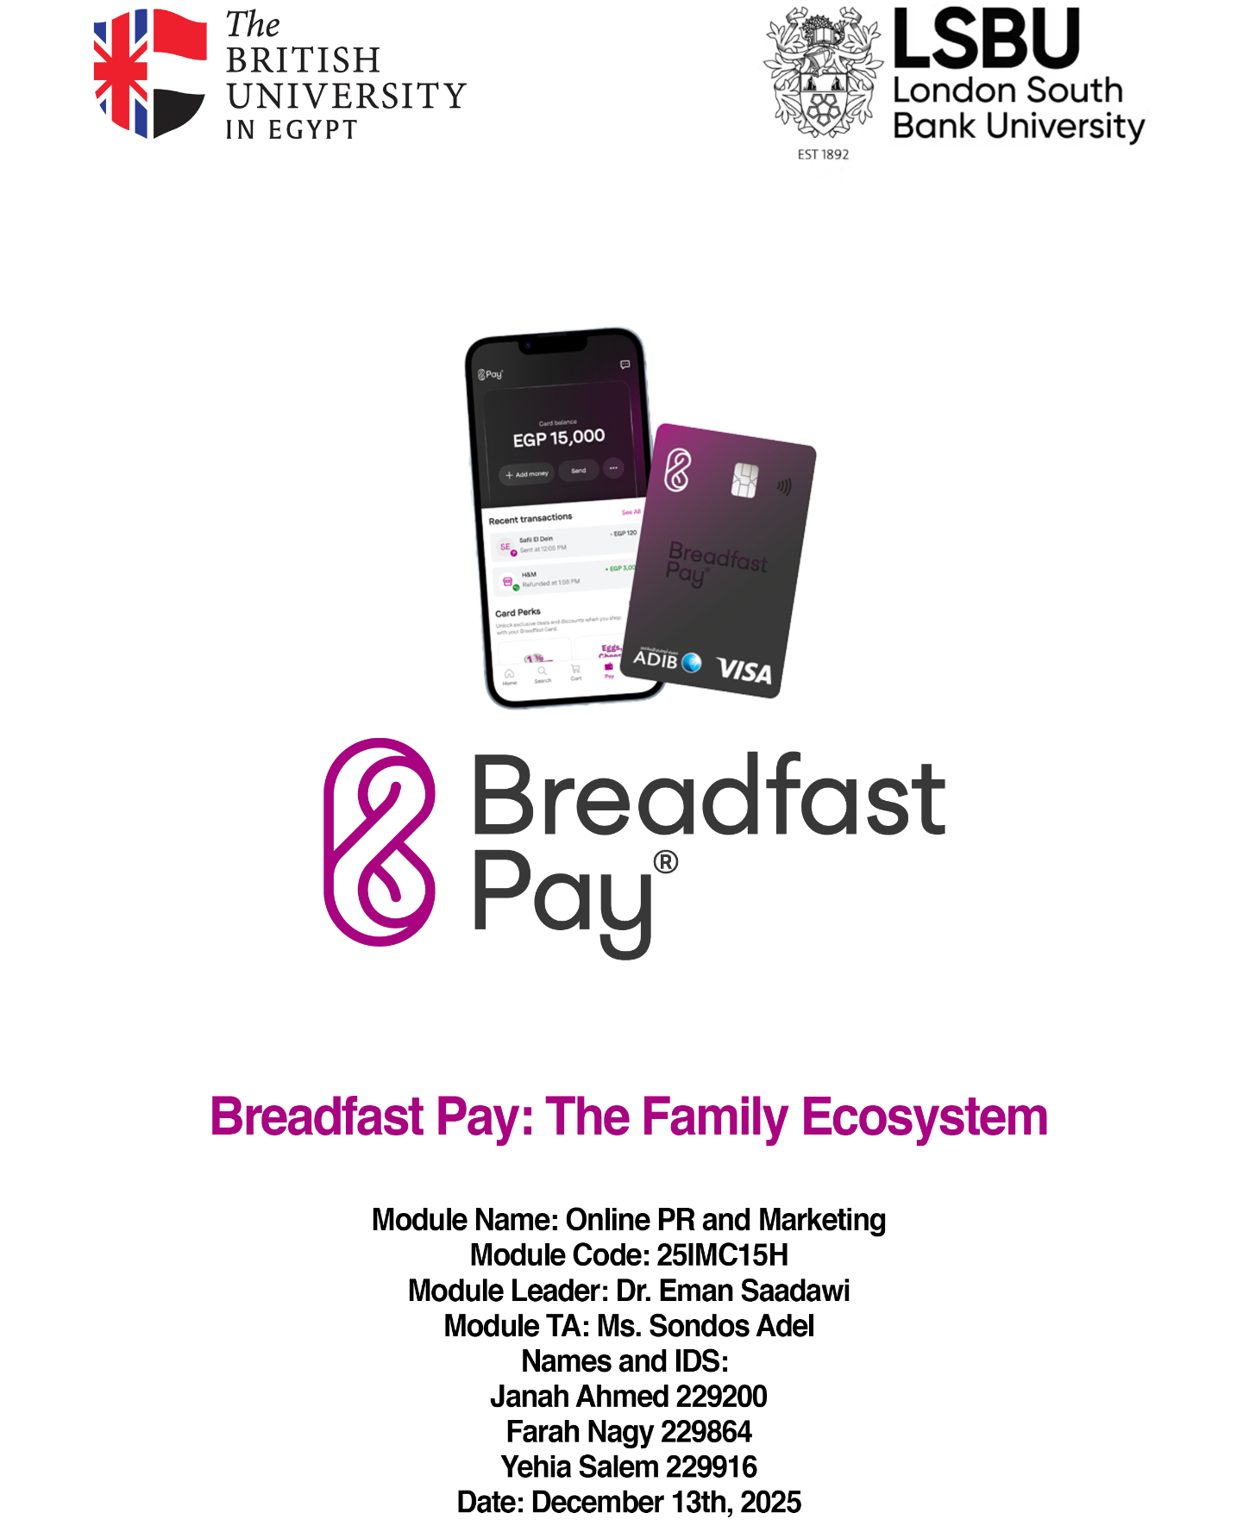

Abstract
This paper outlines the online PR campaign of Breadfast Pay, taking the original grocery app feature and turning it into a comprehensive family payment ecosystem wallet. In response to the current economic climate, where Egyptians are suffering from high inflation, Egyptian households are scrutinizing luxury spending.

The proposed strategy, "One Wallet, Two Lifestyles," leverages a dual-persona approach, targeting moms (the household financial controllers) and Gen Z, with a lifestyle-focused approach targeting children, adults, and adults alike. Unifying grocery spending and lifestyle spending with a selective focus on coffee, Breadfast Pay aims to achieve 400 active family accounts and 1 million EGP in wallet load within a 14-day launch sprint campaign.

The campaign utilizes a PESO model: Paid, Earn, Shared, Owned, with distinct contact tracks for each demographic supported by a thorough measurement plan based on the AMEC framework.

Step 1 — Brand & Challenge

Situation Analysis
The Egyptian market is currently strained by increasing inflation, with households having to prioritize essential spending over items that they do not need, even if they want them. has historically been perceived as a premium grocery service, which poses a risk in a cost-conscious environment across the board, no matter the socio-economic class. Furthermore, there are many competitors in the fintech payment business, therefore, Breadfast needs to position itself in its own quadrant of the market in order to not fall into a “red ocean" and get eaten up by big shots like Fawry, Instapay and Telda (Internal Brief, 2025).

The Challenge
Families are cutting luxuries out of their lives, such as coffee—especially daily specialty coffee—replacing it with sachet over-the-counter coffee in order to manage rising household costs. This behavior threatens the main use case of Breadfast Pay, which is a lifestyle application, if they are only seen as consumption engines and not as management tools for the household.

The Opportunity
Turning the situation and challenge into an opportunity is pivotal for the success of Breadfast Pay. This involves a strategic pivot to position it as both a spending mechanism and a budget management tool, i.e. “the family wallet”. Connecting the grocery budget, which is managed by the parents, and the lifestyle allowance, which is used and craved by Gen Z, Breadfast Pay can become the central financial hub for the entire house (Fintech News Africa, 2024).

Competitive Landscape
A quadrant analysis of the Egyptian fintech market reveals a "Sweet Spot" at the intersection of Family Utility and Lifestyle Aspiration:

- Breadfast Pay: Uniquely positioned in the Family + Lifestyle quadrant.
- Telda / Nexta: Strong on "Lifestyle" and "Individual" appeal (Gen Z focus) but lack the household utility anchor.
- Fawry / Instapay: Dominant in "Utility" but lack the aspirational "Lifestyle" brand equity.
- Klivvr: Attempts the family angle but lacks the high-frequency ecosystem (Groceries + Coffee) that Breadfast owns.

Step 2 — Audience & Insight
• Persona: “Maya, 28-32, Urban Advertising / BTL (Below The Line), main household decision-maker, working mom
• Behaviour: manages the daily spending of the family such as, school needs, groceries, transport, while aiming to remain budget-aware and digitally fluent.
• Barrier: Does not trust financial tools that feel complicated and unfamiliar to the market. Suspicious of apps that promise savings, but do not deliver immediate value.
• Insight: Constantly prioritizing her family’s needs, she seeks a clear financial solution that provides immediate value and a sense of control, without the hassle of mental effort.

• Persona: “Ziad, 18-23, Urban University Student / Fresh Graduate, secondary household spender, tech-native.
• Behaviour: consumes daily specialty coffee, transportation, and outings, while aiming to maximize social experiences but also has a limited allowance or salary.
• Barrier: Dismisses financial tools that are old and "boring" to operate like traditional banking apps. He is suspicious of budgeting apps that restrict freedom without instant gratification or gamified rewards.
• Insight: He is looking for a seamless payment integration that justifies his lifestyle choices through 'hacks' like cashback in an effortless way. He is constantly prioritizing social relevance and convenience.

Step 3 — Objectives (SMART) + AMEC Map
Objective 1: Reach 160,000 unique households across TikTok and Instagram promoting Breadfast pay, achieving at least 1.9% CTR within 14 days.
Objective 2: Generate at least 400 application sign-ups and cashback within 14 days, with a landing-page conversion rate of 5%.
AMEC Map:

- Outputs: Social media content: posts, reels, landing page, and app tutorial snippets.
- Outtakes: Awareness of the advantages of Breadfast Pay, shift in sentiment to be positive by 70% ("Breadfast helps me save money")
- Outcomes: Increase in app downloads, registrations, and engagement with the app features.

Step 4 — Strategy & Message House
• One-line strategy: Highlighting tangible and instant rewards on daily spending , positioning household expenses as a beneficial and rewarding experience.
• Core message (spine): “Get cash back from what you already buy.”
• Proof Points:
- From 5%-10% Cash back on spendings
- Instant rewards on everyday purchases
- A fast, easy, and secure app for household spending.
• Tone of voice & CTA: Dependable, savvy, and simple; CTA: “Sign up today and make every purchase count.”

Step 5 — PESO Channel Mix

Channel | Role | Content Type | Cadence | Budget (EGP)
Paid | Encourage sign-ups and downloads | Instagram & TikTok ads, short videos highlighting (Convenience/ Ease ) & (Rewards / Cashbacks | Non-stop | 111,000 EGP
Earned | Builds trust & credibility | PR to parent and lifestyle creators, and application reviews | 3 Rounds | In-House
Shared | Social proof and boosts community engagement | UGC featuring testimonials or referral challenges | 2-4 posts/week | 80,000
Owned | Conversion from interest to sign ups | Landing page explaining Breadfast Pay benefits, FAQs, and cashback tutorial | Constantly Active | In-House

Step 6 — 2‑Week Content Calendar (with URLs & UTMs)

Date | Channel | Hook | Asset | Owner | URL (with UTM)
Day 1 | Facebook/  Tiktok | Split screen “When you pay with cash vs with Breadfast Pay | 20s Video + captions | Content Creator #1 | https://breadfast.com/pay?utm_source=social&utm_medium=creator&utm_campaign=cash_vs_breadfast&utm_content=split_screen
Day 2 | Instagram | “Girl Math=Coffee is free” | 30s Reel | Influencer | https://breadfast.com/pay?utm_source=ig&utm_medium=creator&utm_campaign=girl_math&utm_content=coffee_free
Day 3 | Facebook | Financial parenting guide | 60s  Video | Brand | https://breadfast.com/pay?utm_source=facebook&utm_medium=video&utm_campaign=financial_parenting&utm_content=guide
Day 5 | Email | "Last Chance" for 20% Off with Breadfast Pay” | Countdown visual with a CTA button “Shop Now” | Brand | https://breadfast.com/shop?utm_source=email&utm_medium=brand&utm_campaign=last_chance_20_off&utm_content=countdown_cta
Day 8 | IG Live | Q&A with Breadfast team member | “Q&A with our Breadfast Expert” + date & time. | Team member | https://www.instagram.com/breadfast/live?utm_source=ig&utm_medium=live&utm_campaign=team_qna&utm_content=promo_visual
Day 12 | Instagram Stories | "Treat Yourself Tuesday" (Cashback) | Graphics of the offer with a CTA (Claim Cashback) | Brand | https://breadfast.com/treat-yourself?utm_source=ig&utm_medium=stories&utm_campaign=treat_yourself_tuesday&utm_content=graphic_cta
Day 14 | Instagram/  Tiktok | “Shared Moments” / “What They’re Saying” | Reposted UGC and testimonials about Breadfast Pay |  | https://breadfast.com/shared-moments?utm_source=ig&utm_medium=ugc&utm_campaign=shared_moments&utm_content=repost

Step 7 — Creators/Influencers Plan

Criteria: 100k-500k followers, focus on everyday lifestyle, parenting, authentic and relevant content.
Brand safety checked: (positive reputations, applicable audience class)

Suggested Creators: Egypt-based mothers and lifestyle macro-influencers @Daliaragheb_ , @Sarahhanyy, and @Nourhan3mad_

Brief: “Pay Fast & Earn Cashback!” Demonstration of how Breadfast Pay helps individuals and families save and earn while buying groceries, coffee, or school supplies. Create content to guide people through registering and cashback rewards. Include a clear and simple CTA to download the app.

Deliverables/Rights:
Stories & Reels: 2-4 stories + 1 reel each, whitelisting for spark ads; 14‑day usage rights in paid/social
TikToks: 1 high‑quality TikTok showing the full cashback moment

Step 8 — Landing Page / Conversion Path

Our goal is to create a high-speed landing page that is optimized for mobile and desktop that explains the family wallet concept and convinces users to download the app and register immediately with appropriate tracking to see who is signing up.
The Wireframe Strategy:
We are using a flow that is streamlined in order to bridge the gap between the moms and Gen Z in a format for the landing page that works for both demographics.
This involves:
- Hero: USP (One Wallet, Two Lifestyles) + Visual Hook (Split screen: Groceries/Coffee).
- Social Proof: Influencer testimonials (Moms & Gen Z creators) to build trust.
- Routine Explainer: A 3-step breakdown of how the shared wallet works.
- CTA (Call to Action): Direct Deep Link to Download App or "Claim Cashback" button.

In-Campaign Example: Breadfast Pay
Our objective is to capture new account sign-ups/leads and drive the first wallet load, which is a conversion.
- URL Example: https://breadfast.com/pay-family
- Wireframe Flow:
  - Hero: "Fuel Your Home & Your Day" + Get 10% Cashback
  - Proof: "I control the budget, he gets his coffee." – Dalia Ragheb
  - Routine: Mom Loads Wallet → Teen Spends → Both Earn Rewards.
  - CTA: "Join the Family (Download App)"

Measurement & Tracking
We will be tracking the landing page using Google Analytics 4 and Firebase in order to ensure that the moms and Gen Z demographics are clicking the links, and who is clicking said links.
- Tracking Events:
  - view_item (Page Load)
  - select_content (Clicking "Download App")
  - generate_lead (Successful Registration)
- UTM Structure: source/medium/campaign/content
  - Example: ?utm_source=tiktok&utm_medium=influencer&utm_campaign=family_wallet&utm_content=gen_z_coffee

WhatsApp Link Pattern (Share with Family)
Since this is a family product used in Egypt, we use a WhatsApp link for the user to easily send a request to their parents to sign up.
Our Implementation:
This link is formatted for the use case of Gen Z sending the link to mom to sign up for the wallet.
Message: "Mom check this out we can get cashback on groceries and my coffee"

Final Link: https://wa.me/?text=Mom%20check%20this%20out%20we%20can%20get%20cashback%20on%20groceries%20and%20my%20coffee%20https://breadfast.com/pay-family

Step 9 — Community Management & Issues
Goal: Reply and interact with the audience quickly, handle clients' questions and concerns.
- Response Window: Reply within an hour, from 10 AM to 10 PM (Africa/Cairo time).
- FAQ / Common Questions:
  - How to register for Breadfast Pay?
  - How to use it for groceries/orders?
  - Cashback and Offers
  - Transaction errors and payment failures
  - Refunds and order issues
- Escalation Guidelines:
  - Payment Failures: (double charge, failed payment): resort to support centre within an hour
Misinformation / user confusion (about features) : Reply with correction and contact the marketing team if complaints are high.
  - Security concerns: Contact security team immediately.
- Listening Keywords:
  - “Breadfast Pay issue”
  - Brand mentions (Breadfast, Breadfast Pay, Breadfast App)
  - “Cashback missing”
  - “Payment error”
  - “unauthorized payment”
  - “account blocked”

Step 10 — Measurement Plan
Goal:
Tracking the top, middle, and bottom of the funnel to see if the family ecosystem positioning for Breadfast Pay is functional and captivating for the target audience of moms and Gen Z. Based on this, we are going to decide if we need to pivot the content styles associated with each target demographic (Bethel University, 2014).
TOFU/MOFU/BOFU = Top/middle/bottom of funnel
- TOFU (awareness): Reach ≥ 160,000 households (across TikTok & IG), video completion ≥ 20% on reels, CTR ≥ 1.9% (aiming higher than standard).
We need to get our videos in front of at least 160,000 families and make sure the content is interesting enough that they do not scroll past immediately.

- MOFU (consideration): Engagement rate (ER) ≥ 4%, sentiment ≥ 70% positive (shifting perception from "expensive grocery app" to "helpful wallet"), high volume of saves on the "Financial Parenting" guides.
We want people to stop seeing us as "just another expensive app" and start trusting us as a helpful tool, proved by them liking, commenting, and saving our guides.
- BOFU (conversion): New Account Sign-ups (Leads) ≥ 400, LP conversion rate (CVR) ≥ 5%, Total Wallet Load ≥ EGP 1,000,000 (sprint goal).
This is where leads actually turn into conversions. We need 400 people to actually sign up and trust us enough to deposit money into the wallet.
- Learning Agenda: Test hooks (Efficiency/Control for Moms vs. Lifestyle/Rewards for Gen Z)
- Test Macro-Influencers (Dalia/Sarah) vs. Spark Ads performance.

We are running an experiment to see if the targeting is working through the control and safety messages for moms or if the lifestyle and work messages are working well for Gen Z, so we know who to target next time.

Step 11 — Budget & Timeline

Total Budget: EGP 200,000 (Allocated for a 14-day launch sprint campaign).
Budget Allocation
Item / Channel | Budget (EGP) | Role / Notes | Timing
Paid Media (IG/TikTok) | 110,000 | Reach 160k households and promote creator posts (Spark Ads) | Days 1–14
Creators (3 Macro) | 60,000 | 1 Reel + 3 Stories each; includes usage rights and whitelisting | Days 1–10
Giveaways/Incentives | 20,000 | Cashback subsidies and prizes to drive app adoption/UGC | Days 7–14
Design/Production | 10,000 | Landing page assets, creative props, and editing | Pre‑launch
Total | EGP 200,000 | Total Campaign Budget | 14 Days

Step 12 — Risks, Ethics & AI Use
Disclosure: Any influencer that was paid, must include #ad in the content they are publishing, or clearly announce it.
Privacy & Consent: Before reposting content, permission from the users must be acquired.
Inclusive & Accurate Content: All content shared must include inclusive language and visuals in order to prevent any legal claims. In addition, the messages should be accurate when it comes to the cashback percentages and benefits.
AI Use: Any AI-generated content (videos, photos, copies) must be revised and approved by a human member and all facts and claims must be re-checked. Additionally, when posting it must include that this is an AI content for authenticity.
Mitigations:
- FAQS will be provided to answer common client questions.
- Crisis management that includes refunds and support centers in case of issues or user complaints.

References
- AMEC Framework. (2025). Integrated Evaluation Framework.
- AUC Caravan. (2025). Student Lifestyle Reports.
- Bethel University. (2014). Strategic Communication Models.
- Cairo 360. (2024). Top Influencers in Egypt.
- CBE (Central Bank of Egypt). (2023). Regulations on Prepaid Cards for Minors.
- Euromonitor International. (2025). Consumer Finance in Egypt.
- Fintech News Africa. (2024). The Rise of Family Banking.
- Meltwater. (2025). Media Monitoring Report: Egypt.
- Misr Connect. (2024). Digital Ad Spend Trends.
- SceneNow. (2025). Visual Trends in Egyptian Advertising.
- Shehata & Partners. (n.d.). Legal Guide to Fintech in Egypt.
- The Guardian. (2025). Gen Z and Soft Saving.
- Treasury.id. (2024). Content Marketing Benchmarks.

Appendix — AI Usage Declaration

Component | AI Tool Used | Purpose/Function
Research and Source Gathering | Gemini 3 Pro Deep Research | Collected and analyzed supporting sources and data.
Tracking Links | Gemini 3 Pro | Helped with the creation of the landing page tracking links

